Task 3: User Login System

Create a program that simulates user login system. You will need to use a C# dictionary whereby you save a few users (each with their own user name and password).

In this program have a directory and I save some static name and password. If input and directory username and password is match then it show welcome username.

**Working Procedure:**

This is a C# desktop base application. In this software have Username, and Password textbox, Output message and a Login button.

In this software at first check the input validation. If the user input is available then it has an static Dictionary and this Dictionary have some username and password. The static Dictionary username and password is : "admin","admin123", "roy", "roy123" , "moni","moni123". When I click login button the system first check the user name is available or not in dictionary. If username is not found then it show an error message “Username wrong..”. If found the username then it check the password are match or not. If password is not match then it show an error message “Password wrong..”. If password and username match then it show an output that is “Welcome ‘username’ ”.

**Algorithm:**

In this program I take input in a variable. Then I create a directory and this directory insert some username and password. Then I check the insert input and directory username and password is match or not. If it matches then it shows Welcome username.

**Exception Handling:**

This program has validation. If I click login without insert any value then it show an error message. If username not match then at show error message. If username match and password is not match then it also shows an error message.

**Code:**

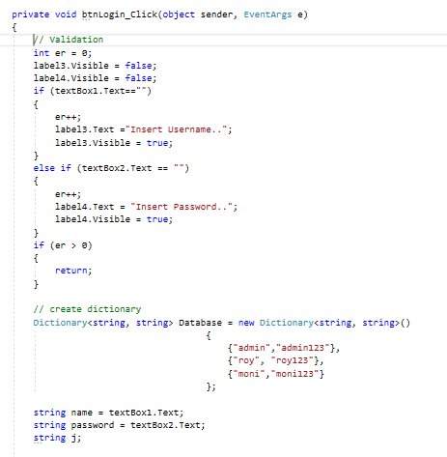

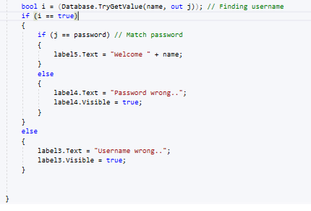

**Output:**

